UNIT TWO: Caring for Ourselves

Lesson 7: Health Habits and Nutrition

**“Five Tips to Stay Healthy”**

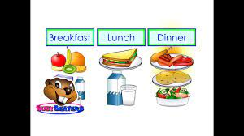Staying healthy is very easy. All you have to do is follow the five tips below/

1. Have three meals a day: breakfast, lunch and dinner. If you get hungry between meals, have a snack. Snacks are a great way to refuel. Choose snacks from different food groups: a glass of milk, an apple or some cereal.

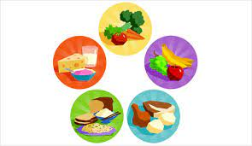

2. It is not good to eat too much of one thing. Your body needs nutrients like protein, carbohydrates, and many different vitamins and minerals. You will have to balance what you eat so that you can get all these nutrients.

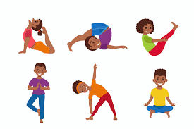

3. exercise is a good way to get your heart working and build up your muscles. Start with a warm-up that stretches your muscles. Then run, jog or dance for twenty minutes. Follow-up with activities that help make you stronger such as push-ups. Finally, cool-down with more stretching and deep breathing.

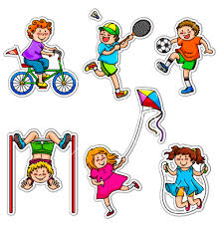

4. Plan activities with family or friends. You can go for a bike ride or you can just go flying a kite. One activity a week with a group will help you feel good, look good and stay fit.



5. Start your day with breakfast. After a long night without food, breakfast is the meal that gets you going. It can actually help you do better in school.

Name: ______________________________ Date: ___________________

1. **List the things that you have to do to stay healthy.**
2. I have to eat the right food.
3. ____________________________________________________________________
4. ____________________________________________________________________
5. ____________________________________________________________________
6. ____________________________________________________________________
7. **Write how each one of the above helps your body.**
8. Food helps my body grow.
9. ____________________________________________________________________
10. ____________________________________________________________________
11. ____________________________________________________________________
12. ____________________________________________________________________
13. ____________________________________________________________________
14. ____________________________________________________________________

Name: ______________________________ Date: ___________________

**Write each sentence correctly.**

1. I ate too much chocolate I became sick.

____________________________________________________________________

1. I had a cavity in my tooth it hurt me all night long.

____________________________________________________________________

1. I know germs are nasty I have to wash every time I play.

____________________________________________________________________

1. I wash with soap to stay clean soap helps me get rid of grime.

____________________________________________________________________

1. **Mrs. Mouna wrote this letter to her friend. She left out all the periods (.) between sentences. Rewrite the letter correctly so her friend can understand when she reads it. Don’t forget to capitalize the beginning of each sentence.**

________________________

__________________________________________________________________________________________________________________________________________________________________________________________________________________________________________________________________________

________________

________________

Dear Thin Friend,

I am very unhappy I have put on a lot of weight my clothes have become very tight I have to see a doctor he will sure put me on diet do you suggest anything I can do?

Love,

Fat Mouna

Name: ______________________________ Date: ___________________

1. **Write the words in the box in the right ovals. Add two more words on the lines under each oval.**

great - stronger - meal - machine - balance - exercise

minerals - deep - amazing

*Words with 2 syllables*

*Words with 3 syllables*

*Words with 1 syllable*

*__________________________________*

1. **use words from the lists above to write three sentences.**

*__________________________________*

*__________________________________*

________________________________________________________________________________________________________________________________________________________________________________________________________________________

Name: ______________________________ Date: ___________________

1. **Join the points of sentences with ‘and’ or ‘but’.**
2. A robot is a machine. It can do the work of a person.

___________________________________________________________________________

1. It does a lot of work. It doesn’t grow.

___________________________________________________________________________

1. It can stand. It can work.

___________________________________________________________________________

1. It has arms. It doesn’t have muscles.

___________________________________________________________________________

1. A robot needs batteries. It needs a person to keep it clean.

___________________________________________________________________________

1. **Write five sentences that tell you how you can stay healthy. Use ‘but’ or ‘and’.**

_______________________________________________________________________________________________________________________________________________________________________________________________________________________________________________________________________________________________________________________________________________________________________________________